**Lacy’s Kiosk**

**System and User Documentation**

Table of Contents

1. Purpose 2

2. Systems Information 2

2.1 System Requirements and Configuration 2

2.2 Installation 2

3. Getting Started 2

3.1 Log-In – Customer 2

3.2 Log-In – Administrator 3

3.3 Log Out 3

3.4 Browse Products 3

4. Menus 4

4.1 Customer Menu Options 4

4.2 Admin Menu Options 4

5. New Accounts 5

5.1 Create New Account 5

6. Customer Product Actions 6

6.1 Add To Cart 6

6.2 Leave Feedback 6

6.3 Check Reviews 7

7. Purchases 8

7.1 View Cart 8

7.2 Update Cart 8

7.3 Place Order 9

8. Admin Product Actions 10

8.1 Add product 10

8.2 Update product 10

8.3 Remove product 10

9. Site Feedback 11

9.1 Customers – Leave feedback 11

9.2 Admin – Review and respond to feedback 11

# 1. Purpose

The software is designed to allow the user to be able to view the products that are available in store, place an order, give feedback, and also get information about some products that may have the store.

Also employees will be able to update the database, maintain the system, and respond to prospective customers.

# 2. Systems Information

## 2.1 System Requirements and Configuration

Operating System: Windows 7  
Program runs on: **Java** 7  Update 5  
Database runs on: SQLite  3.8.8.3  
  
The Lacy’s Kiosk will run in a contained computer station( Like an ATM ) which will be available to customers and employees. The kiosk will have direct access to the store’s database which can be accessed (by wire, or wirelessly), by all kiosks in the store. The Store’s database will maintain, user information ( username, password, etc), inventory information( name, category, quantity, cost, etc), and message information( customer feedback regarding the store, customer feedback regarding items). Customer and Inventory information will be stored in the database, while each individual kiosk’s current session information( items in cart, etc) will be maintained in the kiosk program( the kiosk’s computer memory), and will be cleared at the end of a Kiosk session( when the user logs out)

## 2.2 Installation

Step 1: setup the Kiosk station (Monitor, Touchpad, keyboard, computer, wires) which will be shipped in a singular unit.   
Step 2: setup the store Database, Which can be wired directly to the kiosk, or be connected wirelessly.

Step 3: Connect the kiosk to the database.

Step 4: Begin filling the database with information regarding the inventory of the store, this is done through the kiosk program when logged in with the Admin Account. [ Username: Admin  Password: nimda ]

Step 5: Log out of Admin  
~Your Kiosk is now ready for customer use.

(Note: New inventory, items, and pricing will require adjustment by hand using the Admin account.)

# 3. Getting Started

## 3.1 Log-In – Customer



As a customer, a user doesn’t have to log in. In that case they will be referred to as a Guest and their personal information will not remain in the system. However, if a customer has an account and wants to log in, the process in simple.

1. Enter username and password. Both fields are case sensitive so be mindful.



1. Click **Log In** button.
2. The system will attempt to retrieve the user from the database, determine if the user is a customer and welcome them and display the appropriate home page and menu options.



## 3.2 Log-In – Administrator

Logging in as an administrative user is the same process as logging in as a customer. However, when the system is finding the user in the database, it will determine if the user is an admin account and bring up their appropriate menu options.

## 3.3 Log Out

In order to log out, simply click the **Log Out** button at the top of the screen by the username. The log in panel will return to its previous state of empty username and password fields, the log in button will return, the application will return to the home page, and the previous user’s information will not be in the current memory.

## 3.4 Browse Products

There are multiple categories of products that are available to view. The user can either choose to browse all the items together or only look at a single category at a time.

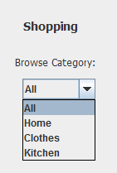

1. The user selects the drop down menu and displays all the category options available.
2. The user selects the category they would like to browse.
3. Once they have chosen a category, the system will take the user to the products page and will generate, fill in, and display product panels for each item in that category.

# 4. Menus

## 4.1 Customer Menu Options

When a customer is navigating the kiosk application, they will have the following menu options available to them:

**Main** – Selecting this option from the Pages drop down menu will bring the customer back to the home page

**Create Account** – Selecting this option from the Pages drop down menu will bring the customer to a page where they can create an account on the system

**My Cart** – Selecting this option from the Pages drop down menu will bring the customer to a page to view the items they currently have in their cart. From this page they can either remove items from their cart, clear their cart, or place an order.

**My Account** – Selecting this drop down menu option will allow the logged in user to view their account information.

**Messages** – Selecting this drop down menu option will allow the logged in user to view their personal messages on the site.

**Browse Category** – This drop down menu on the right side of the screen will provide multiple categories the customer can choose to browse for items.

## 4.2 Admin Menu Options

When an admin is navigating the kiosk application, they will have the following menu options available to them:

**Main** – Selecting this option from the Pages drop down menu will bring the admin user back to the home page

**Add Product** – Selecting this option from the Pages drop down menu will bring the admin to an area where they can provide the information for a new product to add to the database

**Update Product** – Selecting this option from the Pages drop down menu will bring the user to a view of all products so they can find and choose which to update information on.

**Remove Product** – Selecting this option from the Pages drop down menu acts like the update product and shows all products so admin can select which to delete.

**Review Site Feedback** – Selecting this option from Pages drop down menu takes the admin user to a page where they can view the feedback about the site customers have left and the admin will be able to respond.

**Browse Category** – This drop down menu on the right side of the screen will provide multiple categories the admin can choose to browse for items.

# 5. New Accounts

## 5.1 Create New Account

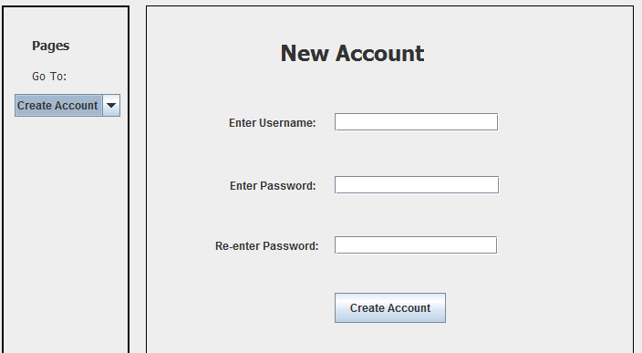

When a customer does not wish to navigate the kiosk as a guest and does not have an account yet, they are able to create one.

1. On the **Pages menu**, click the drop down menu and select **Create Account**. This will bring up the new account page.
2. Enter desired username and password. Remember, these will be case-sensitive so remember if there are capital or lowercase letters.
3. Re-enter password and make sure it matches the password first entered.
4. Click the **Create Account** button.
5. System will make sure no other users have that username already and it will also check if the passwords match. If everything is valid, it will create the new account and return to the main page. Now the new account can be logged in to and the customer can continue navigating the site under their account.

**(Note: If a new admin account is needed to be created, it cannot be done through this kiosk application. The database administrator will need to create the new account and add it themselves straight to the database.)**

# 6. Customer Product Actions

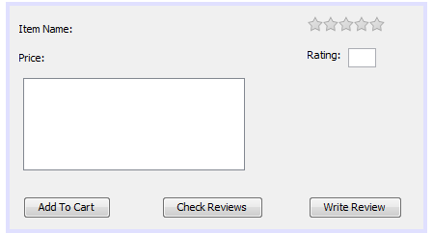

## 6.1 Add To Cart

When viewing products, a customer can choose to add any to their cart if they would potentially like to purchase it later.

1. Navigate to an item would like to add to cart.
2. Click the **Add To Cart** button.
3. A pop up window will appear verifying the product would like to add to cart.
4. Click the **Confirm** button to add to cart or click **Cancel** to simply close the pop up without adding to cart.

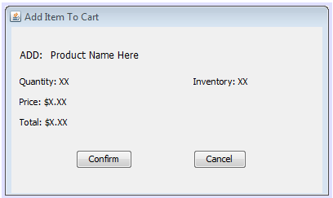

1. The system will add the product to the customer’s cart.

## 6.2 Leave Feedback

After purchasing a product, customers may want to tell others about their experiences and opinions of it. Luckily they have a way to do just that by leaving product reviews or feedback.

1. Navigate to an item to review.
2. Click the **Write Review** button.
3. A pop up window will appear with a panel for the user to fill out.
4. Customer will choose a rating on the star rater and write a review of the product in the text box.
5. Click the **Submit** button to add feedback or click the **Cancel** button to close the window without adding anything.
6. The system will take the information input for the review and add it to the database.

## 6.3 Check Reviews

Before purchasing a product, customers often want to see what other people have to say about it. Customers are able to write and leave their own feedback reviews for products and they are also able to view any of these that others have left for products.

1. Navigate to an item to check.
2. Click the **Check Reviews** button.
3. A pop up window will appear with a panel that the system will populate with the customer product feedback in the system for the selected product.

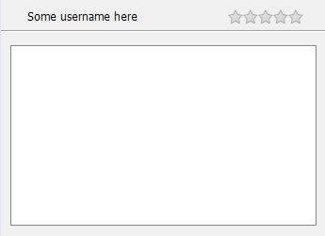

# 7. Purchases

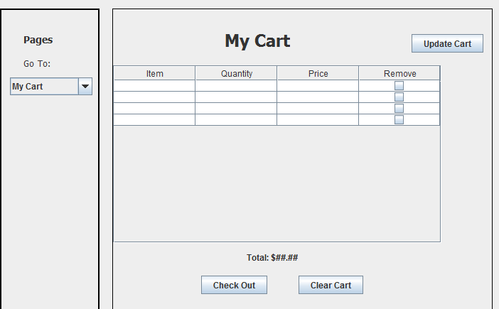

## 7.1 View Cart

AS the customer adds items to their cart, they may want to view what’s currently in there or be ready to purchase. Both can be achieved by taking a look at the cart.

1. Select **My Cart** from the **Pages** drop down menu.
2. The system displays the page that shows a table of the current items in the cart along with a running subtotal of the purchase. The table displays the item name, quantity added, and price of each product in the cart. There is a check box to allow the user to remove an item from the cart.

## 7.2 Update Cart

There are a couple ways to update the cart. The first is by adding items to the cart while browsing through products. The other is by removing items from the cart.

**Remove items one at a time:**

1. Click the checkbox of the product to remove from the cart. Make sure a check is now showing.
2. Click the **Update Cart** button.
3. The system will remove this product from the cart and update the table.

**Remove items all at once:**

1. Click the **Clear Cart** button.
2. The system will remove all the items from the cart and return the user to the main page.

## 7.3 Place Order

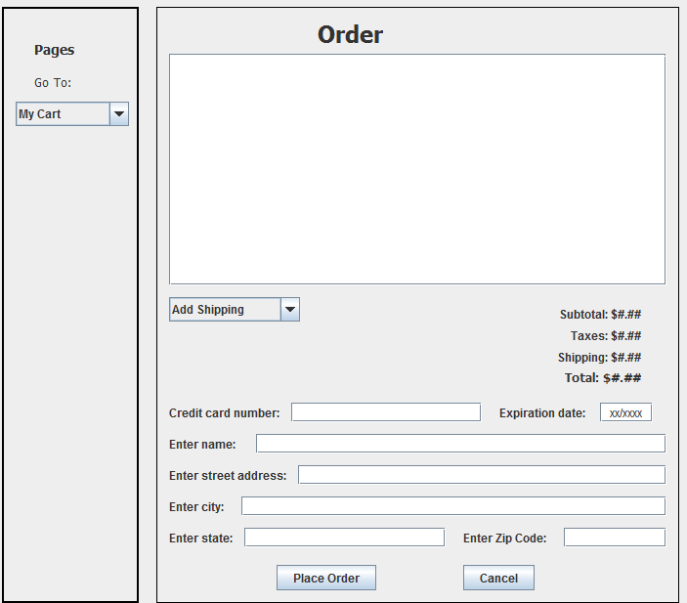

Once the customer has decided they have all the items they want in their cart, they are then ready to make a purchase.

1. From the cart page, click the **Check Out** button.
2. The system will then display the order page with the products in the order displayed as well as the current subtotal.
3. From the **Shipping** drop down menu, select the method of shipping. The options are either Ship to Home or Ship to Store.

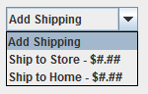

1. The system will update the shipping cost along with the total.
2. Enter the credit card information.
3. Enter the address for the shipping location.

(Note: If the customer is logged in and has chosen Ship to Home, then the system will prepopulate the address fields. User can then type changes if they need to.)

1. The system will update the taxes and total after state field has been entered.
2. Click the **Place Order** button.
3. The system will display a pop up window of the order information for the customer to confirm.
4. Click the **Confirm** button or click **Cancel** to close pop up without adding order to system.
5. The system will add the order to the database and return the customer to the main page.

# 8. Admin Product Actions

## 8.1 Add product

The inventory of Lacy’s is a constantly changing list of products. As administrator user is able to add a new product into the system when one needs to be added. Be sure to have the new product information ready beforehand.

1. Select **Add Product** from the **Pages** drop down menu.
2. A pop up window will display with empty fields for a new product.
3. Fill in all the fields for the product and upload a picture if available.
4. Click the **Add** button to add to system or click **Cancel** button to close window without adding item.
5. The system will validate the entered information, add it to the database as a new product, and return the user to the main page.

## 8.2 Update product

Sometimes a piece of information about a product can change. An admin user will be able to update the necessary product information. The admin can adjust price, amount in stock, name and details of the item.

1. Select **Update Product** from the **Pages** drop down menu.
2. The system will display the product page with the browse all option. The user can browse to a specific category if would like.
3. When find product would like to update, click the **Update** button on that product.
4. A pop up window will appear with editable fields for price, amount in stock, name and details.
5. Enter the new information for whichever fields necessary.
6. Click **Update** button to save changes or click **Cancel** button to close pop up without saving.
7. The system will update the product information in the database with the information entered.

## 8.3 Remove product

Occasionally Lacy’s will decide to no longer carry a product in their inventory. When this happens, the admin user can remove the product from the system.

1. Select Remove Product from the Pages drop down menu.
2. The system will display the product page with the browse all option. The user can browse to a specific category also.
3. When product to remove has been located, click the **Remove** button on that product.
4. A pop up dialog box will display to verify user really wants to remove the listed item.
5. Click **Confirm** button to delete the item or click **Cancel** to close the dialog box without deleting item.
6. The system will set the product for deletion in the database and it will no longer show when browsing the site.

# 9. Site Feedback

## 9.1 Customers – Leave feedback

Customers are able to leave site feedback for Lacy’s store about their kiosk application as well as their products through a feedback feature. The feedback form is located on the Main Page of the application.

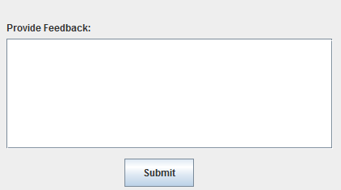

1. Enter message or information for feedback would like to send to Lacy’s.
2. Click the **Submit** button.
3. The system will store the feedback in the database for an admin to be able to retrieve it.

## 9.2 Admin – Review and respond to feedback

Admin users are able to view site feedback left my customer users and respond to them if they choose.

1. Select **Review Site Feedback** from **Pages** drop down menu.
2. The system takes the user to a page that displays the feedback with the most recent ones first.
3. To respond to a feedback message, click the **Respond** button.
4. A pop up window will display with a space for the user to write a reply.
5. Click the **Submit** button.
6. The reply will be sent to the customer who originally sent the feedback.